**2. Some Phenomena Unexplainable by CP in more detail**

**CP** couldn’t explain certain phenomenon (e.g., blackbody radiation, photoelectric effect) which gave rise to the following **new concepts (for the 1900s), that we have encountered so far:**

1. Energy at the atomic level is NOT a continuous variable – it is quantized; E = nhν (Planck).
2. Light has particle-like character: light consists of photons of energy = hν (Einstein)
3. Particles have wave-like character: λ=h/p (deBroglie); manifested at the atomic level.
4. Lines in Atomic spectra → a further indication of the need for a “new physics”

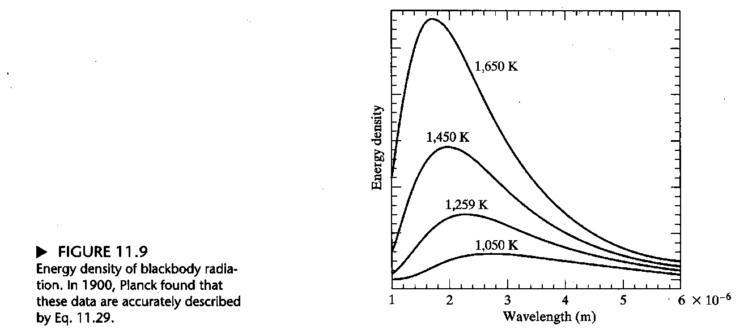

**Blackbody Radiation**

Experimental Observations

**CP** model – B. radiator is composed of individual, discrete oscillators that can operate at any frequency & so can emit & absorb at any frequency → absurd consequences (see below)

**Experimentally** – find a peak in the energy density distribution function; peak shifts to shorter wavelengths as T is increased; the area under the curve (i.e., the total energy density) increases as T is increased.

Some experimental features can be represented by Eqnations:

**1. Wien (1893) Displacement Law:** **T × λmax = constant** (1)

**2. Stefan-Boltzmann law:** **Total energy density**, **ξ** (“Xi”) = Total electromagnetic radiation energy emitted from a region / Volume of the region = E/V) = **a T4** (2a).

Alternatively, this law can be framed in terms of the **Excitance, M** = Power emitted by a region of a surface divided by the Area of the surface of the emitter = **σ T4** where constant

σ [“sigma”] = 5.67 x 10-8 W m-2 K-4 (2b)

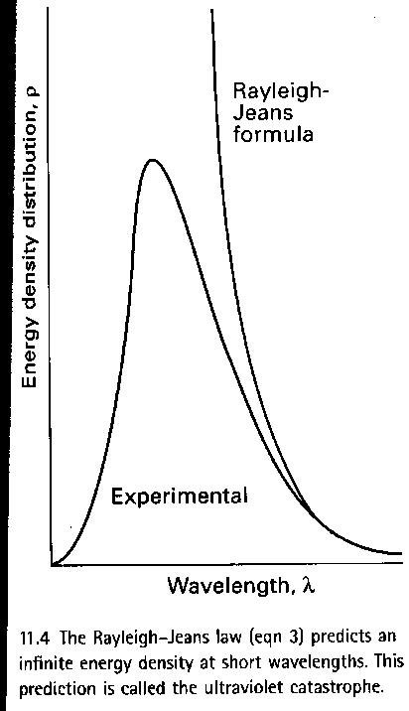**∴** 1 m2 of a blackbody at 1000 K emits 5.67×10-8×10004 = 5.67×104 W when all wavelengths are included.

**Exercise: What is emitted from an area of 1 (mm)2 at T = 1000 K?**

**Rayleigh** tried to explain observations based on CP views at the time (i.e., emitted radiation is due to a collection of oscillators vibrating at all possible frequencies) and obtained the

**3. Rayleigh-Jeans law:**  [“xi” for ξ] (3)

* Results OK at high λ [lamda] (or low ν) but **fail badly at short λ**

**→*The Ultra-Violet (UV) Catastrophe:*** since R-J law ***→ no maximum!***

* It actually says that even cool objects should radiate & that there should be **no darkness!**
* Represents a **severe failing for CP** since such observations also are independent of the material of the blackbody **[Spring 2021]**

**Planck (1900)** – accounted for the experimental observations by proposing that the energy of the individual e-m oscillators is limited to discrete values and cannot be just anything ≡ ***quantization of energies*** (in stark contrast to the CP views at the time).

**Planck** proposed that the permitted **energies** were limited to ***n× (hν)***, with ***n* = 0, 1, 2,** (an integer) and ***h*** is a fundamental constant now called Planck’s constant (6.62607015 × 10-34 Js)*

{Note: The frequency distribution of radiation from a blackbody is represented by function ρν [Rho subscript Nu] = radiation density in the frequency interval between ν and ν + dν: where the units of this distribution function [ρν] are **J s m-3; why?**}

On the basis of this quantization condition (energies limited to integer × hν), Planck derived:

 where kB = Boltzmann constant = R/NA=1.380649×10–23 JK–1*

Note: the energy density between ν and ν + dν (≡ ρν dν) which has units of J m-3, can be converted to an energy density in the wavelength interval λ and λ + dλ (≡ ρλ dλ) using the relationship ν = c/λ and dν = –[c / λ2] dλ, viz. (in this way):

or . **Exercise: what are the units for ρλ? **

Other observations concerning blackbody radiation can be derived from the Planck relationship:

1. **Wien’s Displacement Law**

From dρλ(λ,T)/dT get hc/(λmax kBT) = . Solving for λmax using numerical methods yields λmax (in meters) = 0.2014 hc/(kBT) = 2.898×10-3/T **→** T × λmax = constant.

1. **Rayleigh – Jeans Law**

At low frequency ν, (or high wavelengths): hν/kBT <<1, so the denominator in the ρν expression can be written as 

**∴** At low ν,  but since and ν = c/λ,  so (cf. R-J law above). Note: these are latest CODATA Recommended values from NIST. Both are considered exact.

1. **Stefan-Boltzmann law**

Integrating the distribution function over all wavelengths (= Total Radiant Emittance = Emission per Unit Area per Unit Time) yields the relationship for Total Radiant Emittance:

Total Radiant Emittance (or Emission per Unit Area),  [Xi] as observed; Stefan-Boltzmann constant = J s-1 m-2 K-4 or W m-2 K-4.

Total radiant energy density dependence on T,  , β = 7.56 × 10-16 J m-3 K-4.

# [Heat Capacities

**CP** – mean energy of an atom as it oscillates about its position in a solid is **kBT for each direction of motion** **∴** as an atom oscillates, the **average energy of each atom is 3kBT** so for **NA atoms** (i.e., for 1 mole), the **total energy** (Um) is **3NAkBT** **= 3 R T** since R = NA kB.

**∴** For **all solids**,CV,m (Molar Heat Capacity at constant volume) = ${∂U_{m}}/{∂T}=3R=24.9 JK^{-1}$

BUT this relationship does not work at low Temperatures.

Einstein (1905) derived a better relationship by invoking the Planck quantum hypothesis though Einstein’s formula is not numerically correct. He assumed all atoms oscillated at the same frequency whereas they oscillate over a range of frequencies and not at any frequency. Debye formula gives the correct relationship.

**Bottom line: a quantum condition must be invoked to explain the thermal properties of solids.]**

# Observation of Line Spectra

**CP** – maintained continuous spectra should be seen but that was NOT observed empirically!

**Attempts to explain observed spectra starting with the simplest case, H atom:**

* H atomic emission spectrum consists of a series of discrete lines observed from the UV through the visible region and into the IR (see spectra on a later page).
* Balmer (1885) found he could relate the lines observed in the visible region by the following “simple” relation:

 where *n* is an integer > 2 and RH, (Rydberg constant for H; also see later) =109,677.583 cm-1.

Note 1. A value for R∞ [109,737.31568160 cm-1 is the 2018 CODATA value] is given in Tables of Fundamental Quantities – this is the value for an infinitely heavy nucleus.

R∞ is related to RH by $R_{H}=\frac{R_{∞}}{1+\frac{m_{e}}{m_{p}}}$ = 109,677.58340280 cm-1 (2018 CODATA).

**Verify RH value is correct**. [me = 9.109383701510–31 kg; mp = 1.6726219236910–27 kg].

* Will find according to QM’ics for a single electron, uncharged system, 

where μ [Mu], the reduced mass = , ε0 [Epsilon] = permittivity of free space.

**∴** for mnucleus = ∞, μ = me and R = R∞ = 109,737.31568160 cm-1 = 10,973,731.568160 m-1.

Note 2. Wavelength expressed in cm-1 units is a good unit to employ since it is directly proportional to energy (as is frequency); this makes sense in spectroscopy because all observed lines involve transitions between different energy levels. 

Note 3. As n → ∞, → RH/4 **→** provides an excellent value for the Dissociation Energy

Note 4. Other Series of lines in the H spectrum are produced when integer values different from 2 are used in the 1st term: for n1 = 1, the Lyman Series is observed in the UV; for n1 = 3, the Paschen Series is observed in the near-IR; for n1 = 4, the Brackett Series is observed in the IR.

Note 5. Spectra of atoms with more than 1 electron are more complicated but the observed lines could be produced by assuming that the atoms could only be present in one level of a series of “terms”: all the frequencies (or wavenumbers) for the lines could be calculated by finding the energy difference between the “term” values. The “term” terminology is still retained.

* For absorption between electronic energy levels Em and En, we have:

En



hν

Em

where En and Em are “term” values for the electrons in the atom.

* If the energy of an atom or molecule decreases by an amount ΔE due to emission, this energy is carried away as radiation of frequency ν = ΔE/h producing a line in the observed spectrum.

We now would explain these observations by recognizing that the energy levels in an atom or a molecule are discrete, and that the radiation emitted or absorbed by an atom or molecule consists of discrete frequencies or wavelengths that correspond to the separation of the participating energy levels.

**Exercise: Convert the 1st line in the Balmer series for H, which is 6562.79 Å (in air) to a value in wavenumbers (in air)*. [1/6562.7910-8 cm = 15,237.4218892 cm-1]**

* Note: It is traditional, however, to express wavenumbers in vacuum (we will see how this is done a bit later – need to take the refractive index of air at the wavelength into account for that).

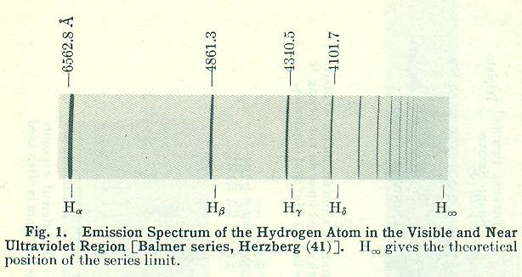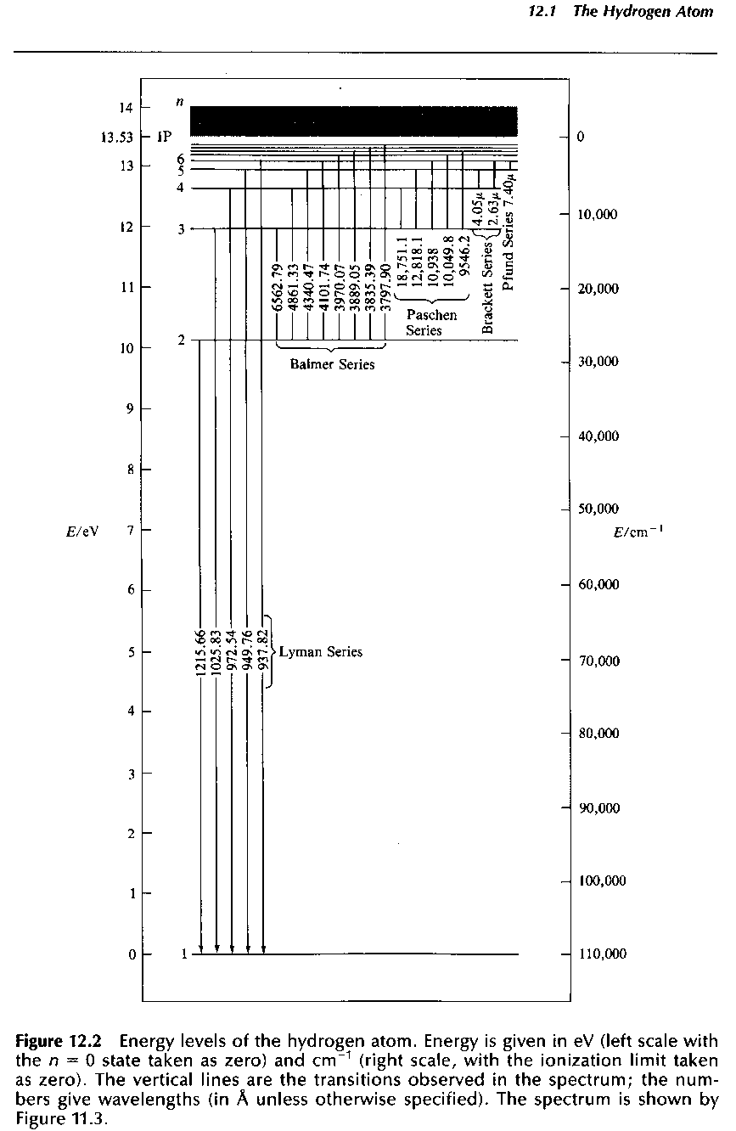**Getting to the Basis of it all (for H) – Bohr Theory for H**

We have not “explained” Planck’s quantum condition as yet, however. **1st successful attempt to do so** came from **Niels Bohr** (Nobel Prize in 1922).

* Recall that in 1911, Rutherford (adduced from experiments where α-particles were scattered from gold foil) concluded that atoms exist as a positively charged nucleus surrounded by negatively charged electrons that orbit the nucleus in circles. BUT according to CP, the orbiting electrons should continuously emit EM radiation (according to Maxwell’s equations), so the atom would lose energy as the electrons spiraled into the nucleus, collapsing the atom. But this was SOMETHING THAT DOES NOT HAPPEN!

In explaining the H atomic spectra, **Bohr made a number of assumptions**. He assumed that the **electron existed in a series of stable energy levels**, that the **observed lines resulted when the electron “jumped” from one energy level to another** but **his key tenet** that determined the electron’s energy levels was the requirement that the **angular momenta of the electron is constrained to be integral multiples of h/2π** [or integral multiples of **ћ** (called “h-bar”)].

**Details of Bohr Theory (1913) for the H atom: Assumptions:**

1. H atom ≡ a +ve nucleus of charge +**e** and an electron of charge **–e** moving around the nucleus in circular orbits where the electron charge = 1.602176634×10‒19 C. (Picture established over the period 1909-1913 by Millikan [& Fletcher] who won the 1923 Nobel Prize for this work).

2. Angular momentum [classically, a vector **L** = m **r** **×** **v**] of orbiting electron is quantized: it can ONLY take integral values of ћ = h/2; no other values for the angular momentum are possible.

3. Maxwell’s equations do NOT apply – radiation is emitted or absorbed by the H atom only when a transition is made between one quantized energy level and another

4. Energy of the emitted or absorbed light is restricted to quantized values called ***photons***, which have energy = h = energy difference between the initial and final states of the H atom.

5. In all other respects, classical mechanics work.

Based on these assumptions, we have the following:

Centripetal force on the electron (Fr) = electrostatic attraction (Fe) between the +ve nucleus and the –ve electron

i.e., Fr = – mv2/r = Fe = –e2/[4 o r2] where r = distance of the electron to the nucleus

From assumption 2, the angular moment of electron = m r v = n ћ (where n = “quantum #”)

**∴** v = n ћ / (m r) and substituting this expression in the equation for Fr we have

Fr = – mv2/r = m n2 ћ 2 / [r m2 r2] = – e2/[4 o r2]

**∴** r3/r2 = radius of electron’s orbit = n2 { ћ 2 4 o / [m e2]} = n2 {h2 o / [m e2]} = ao n2

where ao = 5.29177210903 × 10–11 m is called the **Bohr radius** **→ r is** **quantized ;**

**∴** **Potential energy (V) of a –ve electron** traveling in a circular orbit of radius r around a nucleus of charge e is **V** = – e2/[4 o r] **also is quantized**.

**Kinetic energy of electron** = ½ m v2 and using mv2/r = e2/[4 o r2] in this equation yields:

**K** = ½ e2 r/[4 o r2] = ½ e2/[4 o r] = **½ ⏐V⏐**

**∴**  **Total energy (E) of the H atom**, E = K + V = – V/2 = **– ½ e2/[4 o r2]**

and using r = n2 { ћ 2 4 o / [m e2]} = n2 {h2 o / [m e2]} in this equation gives

**En = – ½ {e2/[4 o r]}{ m e2/[ n2 ћ 2 4 o]}**

**En = – m e4/[2(4 o)2 ћ 2n2] = – m e4 2 2/[(4 o)2h2n2]**

**→ *Energy is quantized***

**“Explaining” the H atom spectrum:**

Energy of the emitted or absorbed photon = the energy difference between 2 energy levels

i.e., Ephoton = E2 – E1 = m e4/[2(4 o)2ћ 2]{1/n12 – 1/n22} = hν = hc/λ

**∴** 1/λ = [E2 – E1]/[hc] = m e4 2 2/[(4 o)2h3{1/n12 – 1/n22}] = RH{1/n12 – 1/n22}

which is the Rydberg relationship we encountered earlier.

Multiplying out gives RH = 10,972,879.90 m-1 = 109,728.7990 cm-1.

This value does not agree with the value given earlier (109,677.581 cm-1) because:

1. we did not used the reduced mass for the electron and proton of the H atom (see the formula given earlier);
2. we also need to correct for wavelengths, λ’s, measured in air vs. vacuum; and
3. for accurate work it is necessary to correct λ for the refractive index of air.

In vacuum, c = co = λoν but in air, c = co/n where c (co) is the speed of light in air (in vacuum), n is the refractive index of air = nair and the value for the refractive index of air also changes slightly with wavelength.

Since the frequency of light stays the same in any medium, the wavelength of light changes with the refractive index of the medium.

i.e., ν = co / λo = c / λ = co / [nair λair] → λo = nair λair and λair =λo / nair

Historically, the convention adopted is to measure and report wavelengths λin air but to define wavenumbers in terms of λo so the correction for the refractive index of air is needed to obtain “proper” wavenumbers. Are formulas for the refractive index of air (e.g., Cauchy formula).

E.g., for wavelength measured to be 5000.0000 Å, ¯ ν (ν-bar) ≠ 20,000 cm–1 precisely.

At this wavelength, nair = 1.0002781 for dry air at the conditions of 15 oC and 760 Torr

→ λo = 5001.3905 Å, so ¯ ν (ν-bar) = 1/5001.3905×10-8 cm = 19,994.43955 cm-1.

But, while Bohr’s formula for RH is in perfect agreement with experimental data, his theory **could not** be extended to any other atoms or species with more than one electron.

***However, this was a start!***

**Compton Effect (1922, 1923)**

{Observed by Arthur Holly Compton in 1923 at Washington University in St. Louis and verified by his graduate student Y. H. Woo. Compton earned the 1927 Nobel Prize in Physics for the discovery.}

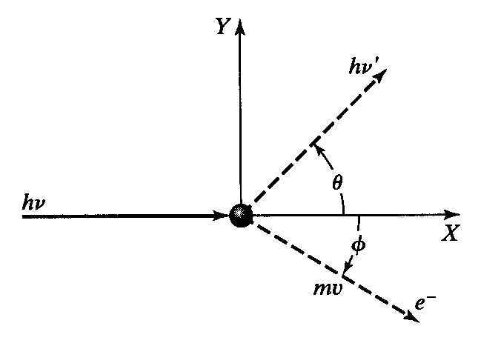Also **illustrates the particle-like nature of light** and confirmed Einstein’s explanation of the Photoelectric (PE) effect.

Compton observed that X-rays scattered by graphite → X-rays of longer wavelength plus emitted electrons.

He considered the process as a collision between an incident X-ray photon and a stationary electron.

Results **could only be explained** from the conservation of the overall momentum if the **momentum** associated with the **X-ray** is **h/λX-ray**

In Compton’s derivation of the scattering formula [A.H. Compton, **Phys. Rev.** **21**, 483 & **22**, 409 (1923)], he took the Planck relationship and the relativistic energy expression for the conservation of energy into account.

We see from the diagram,

Conservation of energy: hνX-ray + mec2= hνX-ray′ + (pe2c2 + me2c4)1/2

Conservation of momentum (considered as vectors): **pX-ray = pX-ray**′ + **pe**

(x-component: pX-ray = pX-ray′ Cosθ + meve Cosϕ; y-component: 0 = pX-ray′ Sinθ - meve Sinϕ)

Squaring the vector equation above using the scalar product yields:

pe2 = (**pX-ray - pX-ray**′) • ( **pX-ray - pX-ray**′) = pX-ray2 **+** pX-ray′2  **-** 2 pX-ray **×** pX-ray′ Cos θ

With the assumptions pX-ray = h/λX-ay (for incident X-ray) and pX-ray′= h/λX-ray′ (for the scattered X-ray), the following equation can be derived:

 where me is the electron rest mass and c is the speed of light.= “Compton wavelength of the electron” = 2.4263×10‒12 m.

Δλ = Compton shift, can be 0 **(for θ = ?º)** and at most twice the Compton wavelength (0.048526 Å) **for θ = ?º** [Cos 0º = 1.000000; Cos 90º = 0.000000; Cos 180º = –1.000000]

[Maximum change occurs when θ = π → Δλ = 0.048526 Å]. Web site for more details of Compton Effect: http://hyperphysics.phy-astr.gsu.edu/Hbase/quantum/compeq.html#c1

i.e., once again this shows that photons have particle-like character with linear momentum, p = hν/c.

[Spring 2021]